Git Version Control System

A version control system is a software that tracks changes to a file or set of files over time so that you can recall specific versions later. It also allows you to work together with other programmers.

The version control system is a collection of software tools that help a team to manage changes in a source code. It uses a special kind of database to keep track of every modification to the code.

Developers can compare earlier versions of the code with an older version to fix the mistakes.

Benefits of the Version Control System

The Version Control System is very helpful and beneficial in software development; developing software without using version control is unsafe. It provides backups for uncertainty. Version control systems offer a speedy interface to developers. It also allows software teams to preserve efficiency and agility according to the team scales to include more developers.

Some key benefits of having a version control system are as follows.

* Complete change history of the file
* Simultaneously working
* Branching and merging
* Traceability

Types of Version Control System

* Localized version Control System
* Centralized version control systems
* Distributed version control systems

Localized Version Control Systems

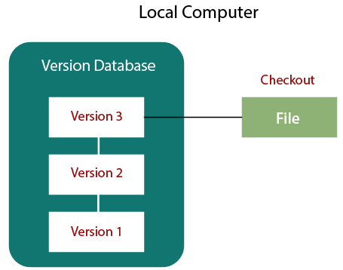

The localized version control method is a common approach because of its simplicity. But this approach leads to a higher chance of error. In this approach, you may forget which directory you're in and accidentally write to the wrong file or copy over files you don't want to.

To deal with this issue, programmers developed local VCSs that had a simple database. Such databases kept all the changes to files under revision control. A local version control system keeps local copies of the files.

The major drawback of Local VCS is that it has a single point of failure.

Centralized Version Control System

The developers needed to collaborate with other developers on other systems. The localized version control system failed in this case. To deal with this problem, Centralized Version Control Systems were developed.

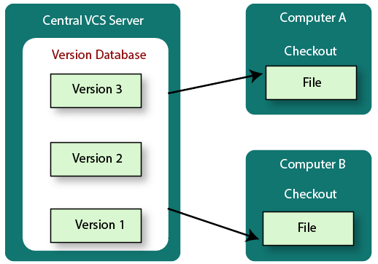

These systems have a single server that contains the versioned files, and some clients to check out files from a central place.

Centralized version control systems have many benefits, especially over local VCSs.

* Everyone on the system has information about the work what others are doing on the project.
* Administrators have control over other developers.
* It is easier to deal with a centralized version control system than a localized version control system.
* A local version control system facilitates with a server software component which stores and manages the different versions of the files.

It also has the same drawback as in local version control system that it also has a single point of failure.

Distributed Version Control System

Centralized Version Control System uses a central server to store all the database and team collaboration. But due to single point failure, which means the failure of the central server, developers do not prefer it. Next, the Distributed Version Control System is developed.

In a Distributed Version Control System (such as Git, Mercurial, Bazaar or Darcs), the user has a local copy of a repository. So, the clients don't just check out the latest snapshot of the files even they can fully mirror the repository. The local repository contains all the files and metadata present in the main repository.

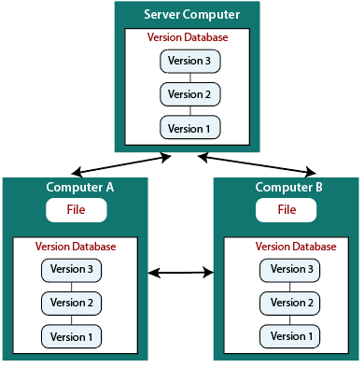

DVCS allows automatic management branching and merging. It speeds up of most operations except pushing and pulling. DVCS enhances the ability to work offline and does not rely on a single location for backups. If any server stops and other systems were collaborating via it, then any of the client repositories could be restored by that server. Every checkout is a full backup of all the data.

These systems do not necessarily depend on a central server to store all the versions of a project file.

Difference between Centralized Version Control System and Distributed Version Control System

Centralized Version Control Systems are systems that use **client/server** architecture. In a centralized Version Control System, one or more client systems are directly connected to a central server. Contrarily the Distributed Version Control Systems are systems that use **peer-to-peer** architecture.

There are many benefits and drawbacks of using both the version control systems. Let's have a look at some significant differences between Centralized and Distributed version control system.

|  |  |
| --- | --- |
| **Centralized Version Control System** | **Distributed Version Control System** |
| In CVCS, The repository is placed at one place and delivers information to many clients. | In DVCS, Every user has a local copy of the repository in place of the central repository on the server-side. |
| It is based on the client-server approach. | It is based on the client-server approach. |
| It is the most straightforward system based on the concept of the central repository. | It is flexible and has emerged with the concept that everyone has their repository. |
| In CVCS, the server provides the latest code to all the clients across the globe. | In DVCS, every user can check out the snapshot of the code, and they can fully mirror the central repository. |
| CVCS is easy to administrate and has additional control over users and access by its server from one place. | DVCS is fast comparing to CVCS as you don't have to interact with the central server for every command. |
| The popular tools of CVCS are **SVN** (Subversion) and **CVS**. | The popular tools of DVCS are **Git** and **Mercurial**. |
| CVCS is easy to understand for beginners. | DVCS has some complex process for beginners. |
| If the server fails, No system can access data from another system. | if any server fails and other systems were collaborating via it, that server can restore any of the client repositories |